Proportional symbol plots: Number and area fractions
Using the program
The Python program prop_plot_legend_2b.py takes a dataset of inclusion compositions and inclusion section areas, and presents these as relative numbers and relative section areas of inclusions, on a ternary composition plot.
Preparing the data
The compositions must be normalized to three elements only, expressed as fractions (normally, mole fractions), with a total of 1. The fractions of elements should be place in three columns, with the section area of each inclusion in the fourth column (this is best done in Excel).
The first row should contain the symbols of the elements to be plotted on the ternary diagram. In the plot, the first element will be at the apex of the composition triangle, the second element bottom right, and the third bottom left. An example of part of a correctly formatted spreadsheet is shown below.
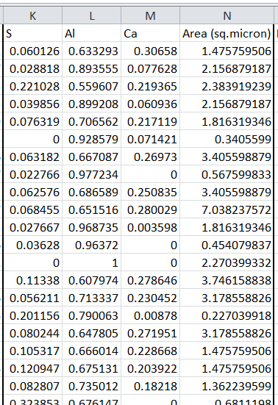
Running the program
To use the program, start the program (typically from within Visual Studio Code). To run the program, you need to have Python and various libraries installed, see later.

As soon as you have started the program, a data input window will open (see below). You will type or paste all the information into the text box at right. Click in this window to start. Enter the sample identifier, then press Enter to start a new line. Enter the analyzed sample area.
Paste the data (compositions and areas) into the text box (see below for an example of how it should look). The data will extend below the bottom of the visible text box. The text box does not have a scroll bar, but you can use “Page Up” and “Page Down” to view all the data if you like. As the example below shows, the data need not look aligned in the text box; the columns just need to be separated by a tab or space (which is automatically the case if the data is pasted from Excel).
Depending on the resolution of your computer screen, you might need to adjust the height:width ratio of the plots, to obtain the plots as equilateral triangles. The aspect ratio is changed by changing the value in the box next to the label “Aspect ratio factor (h/w)”.
The program can add the 50% liquid lines (at 1550 °C) for CaO-Al₂O₃-CaS and CaO-MgO-Al₂O₃ inclusions. To show these, select the appropriate ratio button next to the label mentioning the “50% liquid boundary”.
Once you have pasted in the data (and selected the aspect ratio and 50% liquid boundary, if applicable), simply click on the “Plot” button to generate the proportional symbol plots. As soon as you click “Plot”, the data entry window will disappear, and the plots will appear in a new window.
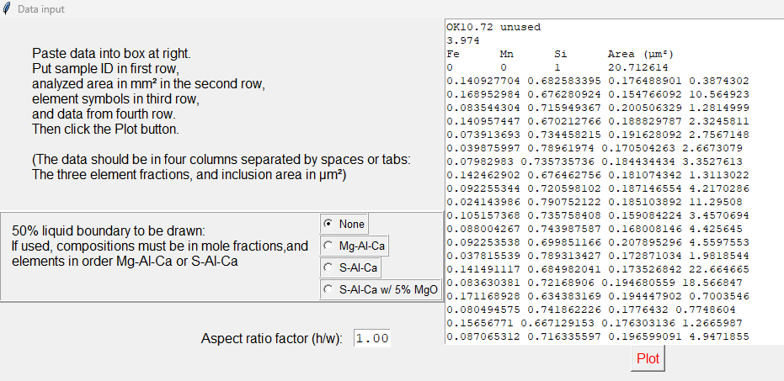
The sample identifier which you entered is added to each plot. The left-hand plot is the number density of inclusions (identified with the label “number”) and the right-hand plot gives the relative area fractions (“area”). To save the figure (as .png by default), click on the disk icon in the lower part of the plot window.
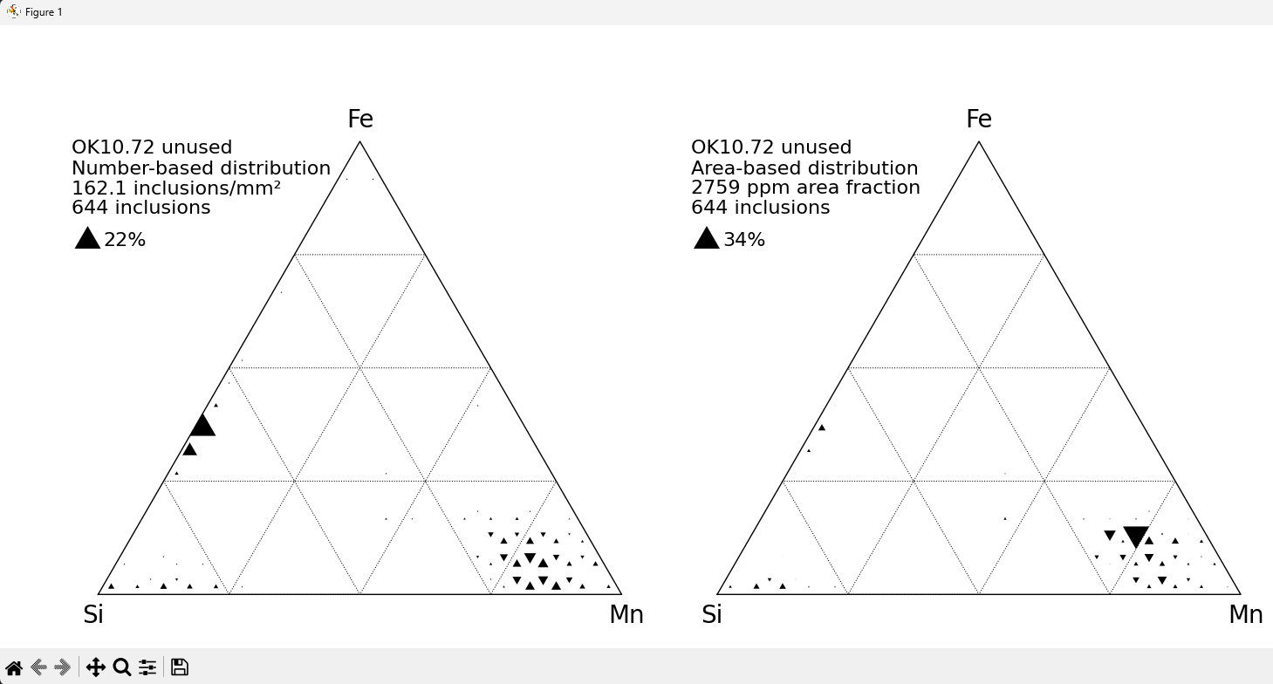
Installing Python
The current version of the program requires you to install Python. There are many versions and libraries of Python. This program uses the numpy and matplotlib extensions, as well as the Python standard modules tkinter and StringIO for data input. The recommended installation is as follows:
Install Visual Studio Code.
Follow the instructions to install the Python extension for Visual Studio Code; install the latest version of Python.
Within Visual Studio Code, open a new terminal, and execute the following commands to install the numpy and matplotlib extensions:
pip install numpy
pip install matplotlib
You can now open and run the Python file (“prop_plot_legend_2b.py”)

Principle of inclusion counting procedure
(This is included for information; it is not necessary to know this to use the program)
To prepare the plots, the ternary composition plot is divided into 400 smaller composition triangles (see diagram below).
Each composition triangle is identified by two indices, in the form [y,x]. The triangle position in the horizontal direction is given by x, starting from zero. Each row of triangles is identified by y, numbered from the bottom (row 0), to the topmost triangle (row 38).
For each inclusion, the program determines in which triangle that composition falls. The program goes through the list of inclusion compositions, and adds the total number and total area of inclusions falling in each composition triangle.
After evaluating all the inclusions, symbols are scaled in the following way:
- The counts (and total areas) are divided by the largest count (largest total area), such that the total for each composition triangle is a number from 0 to 1.
- The width of the triangle plotted on the diagram is then scaled proportional to the total count (or total area), raised to the power 0.57. The exponent 0.57 is used (instead of 0.5, which is what one would expect) because of the human bias to underestimate large areas.
The suitably scaled symbols are then plotted on simple two-dimensional plots. The (x,y) coordinates of the three corners of the ternary plot area are taken to be (0,0), (1,0) and (0.5,1).
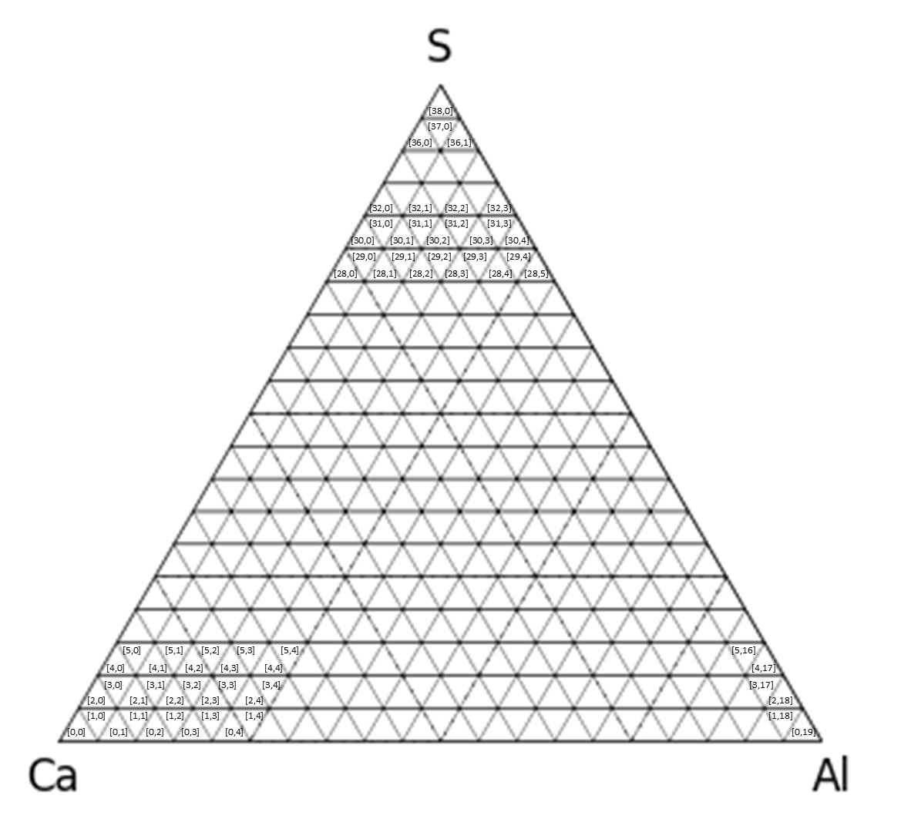

Appendix: Python code
import matplotlib.pyplot as plt
import numpy as np
from tkinter import *
from io import StringIO

# Original software by P. Chris Pistorius
# This version modified March 26, 2016 by Mauro Elias Ferreira and January 10, 2017 by Chris Pistorius
# Modified August 19, 2014 to include adjustable aspect ratio; input widgets on grid layout
# Modified August 21, 2014 to include option of 50% liquid boundaries (chosen with radio button)
# Modified March 8, 2016 to include the S-Ca-Al 50% liquid line with 5% MgO
# include global variables 'maxcount', 'totalcount', 'maxarea' and 'area fraction' to create plot legend
# include plot legend
# Modified March 25, 2016 to include number of inclusions, analyzed area, and number density in legend
# Modified July 22, 2016 to include Area Fraction and some minor aesthetics improvements
# Modified January 10, 2017 - position of legends changed
# Set up class for input
class Application(Frame):
def read_name(self):
name = self.text_entry.get('1.0','1.end')
return name

def read_scanarea(self):
scanarea = self.text_entry.get('2.0','2.end')
return scanarea

def read_elements(self):
elements_string = self.text_entry.get('3.0','3.end')
return elements_string

def read_text(self):
thetext = self.text_entry.get('4.0','end')
return thetext

def read_aspect(self):
aspect_input = self.aspect_read.get()
return aspect_input

def read_button(self):
selected = self.buttonvar.get()
return selected

def createWidgets(self):
self.left_frame = Frame(self,width=300)
self.right_frame = Frame(self,width=300)
self.left_frame.grid (column=0,row=0)
self.right_frame.grid (column=1,row=0)

# Data entry box
self.text_entry = Text(self.right_frame,width=60,font='Courier 10')
self.text_entry.pack(side="top", fill="both", expand=True)

# Button to exit data entry and plot distributions
self.QUIT = Button(self.right_frame, text='Plot', command = self.quit, fg='red', font='Helvetica 12')
self.QUIT.pack(side="top", expand=False)

self.info_frame = Frame(self.left_frame,width=300)
self.info_frame.pack(side="top",fill="both", expand=True)
# Info label
self.info_label = Message(self.info_frame,text = 'Paste data into box at right. \nPut sample ID in first row, '
'\nanalyzed area in mm'+chr(178)+' in the second row, '
'\nelement symbols in third row, \nand data from fourth row. '
'\nThen click the Plot button.'
'\n\n(The data should be in four columns separated by spaces or tabs:'
'\nThe three element fractions, and inclusion area in '+chr(181)+'m'+chr(178)+')',
justify = LEFT, font='Helvetica 12', width=500)
self.info_label.pack(side="top", fill="both", expand=True)

self.liquid_frame = Frame(self.left_frame,width=300,bd=3,relief='ridge')
self.liquid_frame.pack(side="top",fill="x", expand=True,pady=30)
# Selection of 50% liquid border
self.button_label = Message(self.liquid_frame,text = '50% liquid boundary to be drawn: '
'\nIf used, compositions must be in mole fractions,'
'and elements in order Mg-Al-Ca or S-Al-Ca',
font ='Helvetica 12', justify = LEFT, width=400)
self.buttonvar = IntVar()
self.buttonvar.set(1)
self.radio1 = Radiobutton(self.liquid_frame, text="None", variable=self.buttonvar, value=1, font ='Helvetica 10',relief='ridge', bd=2)
self.radio2 = Radiobutton(self.liquid_frame, text="Mg-Al-Ca", variable=self.buttonvar, value=2, font ='Helvetica 10',relief='ridge', bd=2)
self.radio3 = Radiobutton(self.liquid_frame, text="S-Al-Ca", variable=self.buttonvar, value=3, font ='Helvetica 10',relief='ridge', bd=2)
self.radio4 = Radiobutton(self.liquid_frame, text="S-Al-Ca w/ 5% MgO", variable=self.buttonvar, value=4, font ='Helvetica 10',relief='ridge', bd=2)
self.button_label.grid(column=0, row=0, rowspan=3,sticky=(W), padx=5)
self.radio1.grid(column=1,row=0, sticky=(W))
self.radio2.grid(column=1,row=1, sticky=(W))
self.radio3.grid(column=1,row=2, sticky=(W))
self.radio4.grid(column=1,row=3, sticky=(W))
self.liquid_frame.columnconfigure(0,weight=2)
self.liquid_frame.columnconfigure(1,weight=1)

# Aspect ratio adjustment
self.aspect_frame = Frame(self.left_frame,width=400)
self.aspect_frame.pack(side="top",fill="x", expand=True)
self.aspect_entry_label = Label(self.aspect_frame,text = 'Aspect ratio factor (h/w):', font='Helvetica 12')
self.aspect_read = StringVar()
self.aspect_read.set("1.00")
self.aspect_entry = Entry(self.aspect_frame, textvariable = self.aspect_read, font='Courier 12',width=4)
self.aspect_entry_label.grid(column=0, row=0, padx=5, sticky=E)
self.aspect_entry.grid(column=1, row=0, sticky=W, padx=5)
self.aspect_frame.columnconfigure(0,weight=4)
self.aspect_frame.columnconfigure(1,weight=1)

def __init__(self, master=None):
Frame.__init__(self, master)
self.grid()
self.createWidgets()

# Function definitions
def fifty_border(border_id):
if border_id==1: #No border
border=np.array([[None,None]])
else:
if border_id==2: #Mg-Al-Ca
border=np.array([[0.365032404,0.000677813],[0.35563025,0.00808425],[0.347267506,0.013063513],
[0.34134393, 0.015498229],[0.333019505,0.017095228],[0.328084781,0.016872357],
[0.322164202,0.015266216],[0.255497535,0.015266216],[0.253065314,0.019813228],
[0.252456616,0.020940935],[0.249759712,0.025845845],[0.232702212,0.191730845],
[0.238152986,0.19452243], [0.248515347,0.200822099],[0.25746506,0.208121414],
[0.268907602,0.222475978],[0.27232843, 0.229035318],[0.27547624,0.237240398],
[0.278143498,0.248161274],[0.444802793,0.580420139],[0.45359720,0.574607743],
[0.462724434,0.56892917], [0.4753947, 0.56140431], [0.489318785,0.553277609],
[0.498001526,0.548148194],[0.511992018,0.53963882], [0.74948106,0.058342621],
[0.753643575,0.046977885],[0.758559568,0.033484911],[0.762792159,0.02180387],
[0.766884035,0.010403411],[0.769960001,0.001772978]])
border[:,0]=1.0-border[:,0] #reverse, because coordinates given above are for Mg-Ca-Al, not Mg-Al-Ca

else:
if border_id==3: #Ca-Al-S
border=np.array([[0.2285248,0.001213213],[0.226548781,0.004535424],[0.223273286,0.011189832],
[0.221426973,0.015367361],[0.219320712,0.020405509],[0.215903388,0.029075314],
[0.213958022,0.034243121],[0.211595805,0.040721085],[0.302825602,0.351680634],
[0.304920635,0.350844053],[0.310331779,0.348979614],[0.317080755,0.347129888],
[0.326813852,0.345108199],[0.340377852,0.343110784],[0.350771607,0.342017799],
[0.360413547,0.341260778],[0.366314889,0.340903448],[0.368094261,0.340810739],
[0.631001359,0.016730337],[0.631200659,0.015771308],[0.631668719,0.013666008],
[0.632173773,0.011487258],[0.63302285,0.007865833], [0.63417212,0.00208874],
[0.634263352,0.000467697]])

else: #Ca-Al-S w/ 5%MgO
border=np.array([[0.233713485,0],[0.224403093,0.018399968],[0.220820137,0.027442363],
[0.217440358,0.036378768],[0.227124827,0.086481716],[0.248012014,0.159271635],
[0.265793104,0.221388114],[0.281286131,0.274994219],[0.288312902,0.299129784],
[0.294890391,0.321718794],[0.302064568,0.342702564],[0.301396173,0.343798013],
[0.304486221,0.350340043],[0.312390686,0.358497184],[0.322781529,0.35720758],
[0.342769667,0.353279007],[0.362653133,0.351255223],[0.381415509,0.34633915],
[0.399040939,0.336554739],[0.442184014,0.306208165],[0.444742374,0.303817769],
[0.451939801,0.29208683],[0.51000036,0.238399942],[0.572466654,0.1822383],
[0.63524313,0.124068806],[0.666280382,0.094144914],[0.68638496,0.075785483],
[0.711699038,0.05102182],[0.739405007,0.025726428],[0.750527145,0.012947905],[0.758453234,0]])

return (border)

def draw_frame(width, resolution, line_width, labelA, labelB, labelC, ID, aspect_ratio): # width in inches, resolution in dpi, line_width in pixels
"Procedure that draws frame for ternary diagram"
global fig, axes, axes2
frame=np.array([[0,0],[1,0],[0.5,1],[0,0]], dtype = float) # coordinates of ternary frame
grid_coord=np.array([[0.25,0],[0.125,0.25],[0.875,0.25],[0.75,0],[0.375,0.75],[0.625,0.75],
[0.25,0],[0.5,0],[0.25,0.5],[0.75,0.5],[0.5,0]])
width=width*1.1/0.8
height=width*(3.0**0.5)/4*aspect_ratio # height is 0.866 times width, for equilateral triangle
fig = plt.figure(figsize=(width,height), dpi=resolution, facecolor='white') #set image area to achieve correct aspect ratio

# set up axes for left hand plot
axes = fig.add_axes([0.05, 0.05, 0.4, 0.8]) # left, bottom, width, height (range 0 to 1)
axes.set_ylim([-0.05,1.05])
axes.set_xlim([-0.05,1.05])
axes.axis('off')
axes.plot(frame[:,0],frame[:,1],color='black', linewidth=line_width) # draw frame of ternary plot
axes.plot(grid_coord[:,0],grid_coord[:,1],color='black', linewidth=line_width*0.75, linestyle=':') # draw grid of ternary plot
axes.text(0.5,1.02,labelA,ha='center',va='bottom') # Label the corners
axes.text(1.01,-0.02,labelB,ha='center',va='top')
axes.text(-0.01,-0.02,labelC,ha='center',va='top')
ID_label = ID+'\nNumber-based distribution'
axes.text(-0.05,0.92,ID_label,ha='left',va='bottom',fontsize=8) # Label plot with sample ID

# set up axes for right hand plot
axes2 = fig.add_axes([0.48, 0.05, 0.4, 0.8]) # left, bottom, width, height (range 0 to 1)
axes2.set_ylim([-0.05,1.05])
axes2.set_xlim([-0.05,1.05])
axes2.axis('off')
axes2.plot(frame[:,0],frame[:,1],color='black', linewidth=line_width) # draw frame of ternary plot
axes2.plot(grid_coord[:,0],grid_coord[:,1],color='black', linewidth=line_width*0.75, linestyle=':') # draw grid of ternary plot
axes2.text(0.5,1.02,labelA,ha='center',va='bottom') # Label the corners
axes2.text(1.01,-0.02,labelB,ha='center',va='top')
axes2.text(-0.01,-0.02,labelC,ha='center',va='top')
ID_label = ID+'\nArea-based distribution'
axes2.text(-0.05,0.92,ID_label,ha='left',va='bottom',fontsize=8) # Label plot with sample ID
return
#
def find_indices(divisions,x,y):
"Procedure to locate composition point in composition triangle"
x_size=1.0/divisions
y_size=1.0/divisions
if abs(1-y)<y_size:
tri_x=0
tri_y=(2*divisions-2)
else:
offset=-1 if (1.0*int((x-y/2.0)/x_size)==((x-y/2.0)/x_size)) and ((x-y/2.0)/x_size > 0) else 0
tri_x = int((x-y/2.0)/x_size) + offset # calculate x index of composition triangle
x_edge = x_size*(1.0+tri_x+0.5*int(y/y_size))
tri_y = 2*int(y/y_size) + \
(x > (x_edge - 0.5*(y-y_size*( int(y/y_size) ) ) ) ) # y index of triangle
return [tri_x,tri_y]
#
def count_inclusions(divisions,x,y,areas):
"Procedure that counts inclusions and returns array of counts"
global maxcount, percentage, totalcount, maxarea, area_fraction, total_af
counted = np.zeros(shape=(2*divisions-1,divisions),dtype=float) # set initial counts to zero
areacounted = np.zeros(shape=(2*divisions-1,divisions),dtype=float) # set initial area counts to zero
for i in range(len(x)): # Iterate over the total set of inclusion compositons
if x[i] != None: # ...except invalid compositions, as flagged when these were read
tri_xy = find_indices(divisions,x[i],y[i])
counted[tri_xy[1],tri_xy[0]] += 1
areacounted[tri_xy[1],tri_xy[0]] += areas[i]
maxcount=np.max(counted)
percentage = maxcount/np.sum(counted)*100
totalcount=np.sum(counted)
maxarea=np.max(areacounted)
area_fraction=maxarea/np.sum(areacounted)*100
total_af=np.sum(areacounted)/float(scanned_area)
counted=((counted/maxcount)**0.57) * 1.0/divisions # note exponent 0.57 rather than 0.5
areacounted=((areacounted/maxarea)**0.57) * 1.0/divisions # note exponent 0.57 rather than 0.5
return ([counted,areacounted])

#
def make_triangles(divisions,scale):
"Function that creates polygons to plot proportional symbols"
y_divisions=2*divisions-1
el_width=1.0/divisions
polytri = np.empty(shape=(0, 2),dtype=float) # initialize array of polygon coordinates
for j in range(y_divisions): # iterate over y dimension (rows)
imax = divisions - j//2 - j%2 # maximum x index for this y row
x_start = ((j+1)//2 + 1) * el_width/2 # center of first triangle in x direction
y = (3*(j//2) + 1 + j%2) * el_width/3 # center of triangles in y direction
y_sign = 1.0*((j%2)*2-1) # controls whether triangle points up or down
for i in range(imax):
x=x_start + el_width*i
polytri=np.append(polytri,[[x-scale[j,i]/2,y+y_sign*scale[j,i]/3],
[x+scale[j,i]/2,y+y_sign*scale[j,i]/3],
[x,y-y_sign*scale[j,i]*2/3],
[None, None]],axis=0)
# Add triangle for legend, centered on x=-0.02; y=0.78
polytri=np.append(polytri,[[-0.02-0.5*el_width,0.78-el_width/3],
[-0.02+0.5*el_width,0.78-el_width/3],
[-0.02,0.78+el_width*2/3],
[None, None]],axis=0)
return (polytri)

#Main program
divisions=20 # number of divisions along each of the composition axes
# Set up data input window
root = Tk()
root.title('Data input')
app = Application(master=root) # Open data entry window
app.mainloop() # Wait for data entry
sample_id = app.read_name() # Read sample ID from first line
scanned_area = float(app.read_scanarea())# Read scanned area from second line
elements = StringIO(app.read_elements()) # Read column headers from third line
A,B,C = np.genfromtxt(elements, usecols=(0, 1, 2), dtype = str, unpack=True) # Read element labels
text_in = StringIO(app.read_text()) # Read entered text containing values to be plotted, from fourth line
a_data,b_data,c_data,area_data = np.genfromtxt(text_in, usecols=(0, 1, 2, 3), unpack=True) #...and convert to arrays
# Test that all compositions are non-negative and convert to x-y coordinates
x_data=[(b_data[i]+a_data[i]/2.0) if ((a_data[i]>=0) and (b_data[i]>=0) and (c_data[i]>=0)) else None for i in range(len(a_data))]
y_data=[a_data[i] if ((a_data[i]>=0) and (b_data[i]>=0) and (c_data[i]>=0)) else None for i in range(len(a_data))]
asp_ratio = float(app.read_aspect())
boundary = app.read_button() # read in which 50% liquid boundary to draw
get_border=fifty_border(boundary) # ...and retrieve the coordinates of the appropriate boundary

# Close data entry window
root.destroy()

# now count the inclusions and calculate linear dimensions of the symbols
counts=count_inclusions(divisions,x_data,y_data,area_data) # item 0 in counts is number distribution, item 1 area distribution
count_triangles=make_triangles(divisions,counts[0]) # convert symbol sizes to polygons: number count
area_triangles=make_triangles(divisions,counts[1]) # convert symbol sizes to polygons: areas
draw_frame(6.0,200,0.5, A, B, C, sample_id,asp_ratio) # set up figure and axes
axes.fill(count_triangles[:,0],count_triangles[:,1],facecolor='k',edgecolor='none') #draw polygons of proportional symbols - number count
axes2.fill(area_triangles[:,0],area_triangles[:,1],facecolor='k',edgecolor='none') #draw polygons of proportional symbols - area count
axes.plot(get_border[:,0],get_border[:,1],color='grey', linewidth=0.5) # draw 50% liquid boundary
axes2.plot(get_border[:,0],get_border[:,1],color='grey', linewidth=0.5) # draw 50% liquid boundary

axes.text(-0.05,0.915,str(round(totalcount/scanned_area,1))+' inclusions/mm'+chr(178)+'\n'+str(int(totalcount))+' inclusions',
ha='left',va='top',fontsize=8) # Show inclusion number density (i.e. inclusions/scanned area) and total number of inclusions
axes2.text(-0.05,0.915,str(int(total_af))+' ppm area fraction'+'\n'+str(int(totalcount))+' inclusions',
ha='left',va='top',fontsize=8) # Show inclusion area fraction and total number of inclusions

axes.text(-0.04+1.0/divisions,0.78,str(int(percentage))+'%',ha='left',va='center',fontsize=8) # Number percentage of largest triangle
axes2.text(-0.04+1.0/divisions,0.78, str(int(area_fraction))+'%',ha='left',va='center',fontsize=8) # Area percentage of largest triangle

plt.show() # Show plot

J.J. Flannery: Canadian Cartographer, 1971, vol. 8, pp. 96–109.

